|  |  |  |
| --- | --- | --- |
|  | Year 11 Mathematics-Specialist  Unit 2 Test 2 - Matrices |  |

Unit 2 Test 2 – Part One

Time Allowed : 25 minutes

Student Name : _______________________________________

This task comprises two sections

Part One – Resource Free

Part One contains 5 questions worth 27 marks

**Question 1 (**Question 3 2014 WATP CF) **4 marks**

(a) If  determine

(i) 2**PQ** (2)



(ii) **QP** – **P** (2)



**Question 2 6 marks**

Let A,B and C be 2 arbitrary matrices, and 

Write T (True) and F (FALSE) for each of the following equations:

a) **AB**-**BA**=0 b) **AI** –**IA** = 0

FALSE TRUE

c) (**A**+**B**)2 = **A**2 + **B**2 d) **AO** = **O**

FALSE TRUE

e) (**AB**)-1 = **A**-1**B**-1 f) (**AB**)**C** = **A**(**BC**)

FALSE TRUE

**Question 3 9 marks**

Square matrices **X**, **Y** and **Z** are such that **XY**=**Z**.

a) Express matrix **Y** in terms of matrices **X** and **Z**. (1)

XY = Z

X-1 XY = X-1 Z

Y = X-1 Z

b) Hence or otherwise, determine a 2x2 matrix **Y** if matrices **X** and **Z** are as shown below.

(3)





c) Show that the determinant of **XZ** is equal to the product of the determinant **X** and determinant **Z** i.e. det **XZ** = det **X** . det **Z** (5)



**Question 4** (Q1 APPLICABLE 2007 – from 3AB Doc SCSA **6 marks**

Let **A** = , **B** = , **C** = 

(a) In the product matrices below, fill in the missing entries [ ] with the correct values.

(i) **AC** =  (2)

(ii) **CB**=  `(2)

(b) Is it possible to find two matrices **X** and **Y** such that **XY** is defined but **YX** is undefined? Justify your answer*.* (2)

YES

The above example shows C3x2B2x2 is possible but B2x2C3x2 is not as the columns in the first matrix must be the same as the rows in the second matrix

**Question 5 2 marks**

By considering the geometrical effects the following transformations have on the points (1,0) and (0,1), state the matrix representing

a) reflection about the y-axis b) rotation of 180° about the origin.

 

|  |  |  |
| --- | --- | --- |
|  | Year 11 Mathematics-Specialist  Unit 2 Test 1 - Matrices |  |

Unit 2 Test 2 – Part Two

Time Allowed : 35 minutes

Student Name : _______________________________________

Part Two – Calculator & Notes Allowed

Part Two contains 6 questions worth 38 marks

**Question 6 7 marks**

a) Find the greatest value of λ that makes the matrix  singular. (4)





b) If  find  in the form p**M**+q**I** (3)



**Question 7 4 marks**

Consider the simultaneous equations 

a) Write this system as a matrix equation. (1)



b) Solve the system using matrix methods. (3)



**Question 8 8 marks**

Find the coordinates of the image of A(0,0) B(3,0) C(3,1) D(0,1) when ABCD is transformed by the matrix A, where  (2)



A(0,0) B(0,-3) C(1,-3) D(1,0)

b) Describe with the aid of a diagram, the geometric effect of matrix A on the rectangle ABCD. (2)

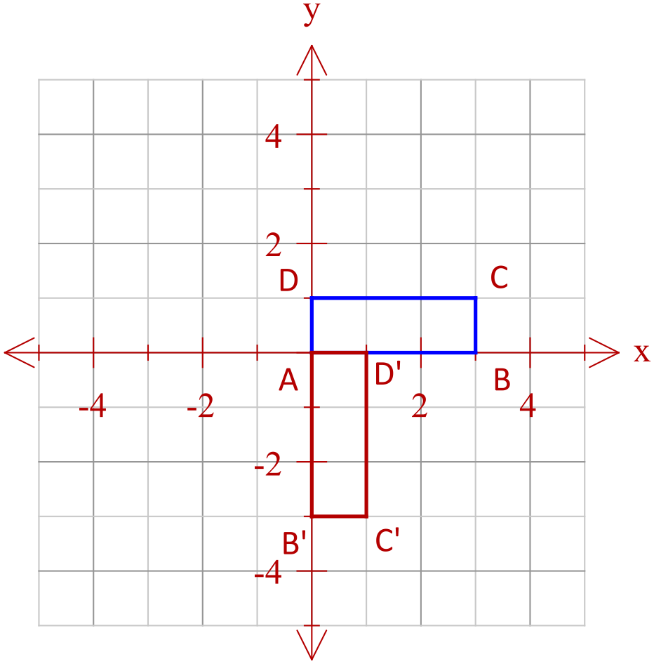

Rotation of 90˚ clockwise around the origin

c) Find **A**4. (1)



d) Explain, geometrically, the result of (c). (1)

4 applications of the matrix A, a 90˚ clockwise rotation about the origin results

in the image being returned to its original position

e) Find a 2x2 matrix which maps rectangle which maps ABCD to WXYZ with W(0,0) X(6,0) Y(6,3) and Z(0,3). (2)



**Question 9 (WAEP 2012 Y12 3CDMAS S2 q10) 8 marks**

A triangle with vertices at ,  and  is to be reflected in the *x*-axis and then rotated  anticlockwise about the origin.

a) Find the matrix that will combine these two transformations in the order given. (2)



b) Find the coordinates of  after transformation by . (1)

 C’(4,3)

c) Another transformation matrix is given by .

Determine the area of triangle A’’B’’C’’ after transformation by  and then by . (3)

 ( or|**T**| = -1, |**R**| =0.36 )



New area =0.36 x original area

=0.36 x 3

= 1.08 sq units

e) Find the matrix which will transform A’’B’’C’’ to ABC. (2)

Matrix required is (**RT**) -1



**Question 10 8 marks**

On a normal Monday’s trading, BRASH’S Melville store sell, on average, the 8 televisions, 12 music systems and 6 digital video recorders. In comparison, the Cannington store sells, on average, 4 televisions, 9 music systems and 5 digital recorders.

a) Represent this information as the matrix **S**. (2)

**T M D**



b) The profits ($) on each item can be represented by matrix **P**, where **P** =  (2)

Calculate SP. 

What do the entries tell you?

The amount of profit at each stores on a normal Monday



For their MAD MONDAY SALE, profits were reduced by 40% and the following quantities sold.

Melville : 9 televisions, 8 music systems and 10 digital video recorders

Cannington : 8 televisions, 13 music systems and 15 digital video recorders

c) Use matrix operations to determine the overall increase or decrease in profit for the two stores on MAD MONDAY over a normal Monday. (4)



A decrease in profits of $750 (Dec of 780 Mel, Inc 830 Cann)

**Question 11 3 marks**

Find the image of the in line  after it is reflected in the line .

